What’s Covered in PeopleSoft: How to view and edit your work/residence state(s), state tax distribution(s) and update and submit your federal and state tax form(s).

Contents
General Information: 1
Viewing and Editing Your Information 2
Update Work/Resident States Tile 2
Update State Tax Distribution Tile 4
For Exempt Employees 4
For Hourly / Overtime Eligible Employees (Time Reporters) 5
Update Tax Withholding Tile 6

General Information:
- Follow your school or unit’s requirements and processes regarding flexwork. Visit the Flexwork at Harvard website for more information about Harvard’s Flexwork Policy and Guidelines.
- If an employee has been approved for flexible work, current guidelines state that the employee must work from a Harvard registered payroll state and have taxes (where applicable) withheld for that state. Effective 10/1/2021, Harvard registered payroll states include:
  - New England states (Connecticut, Massachusetts, Maine, New Hampshire, Rhode Island, and Vermont)
  - California
  - Maryland
  - New York
- Harvard expects individuals regularly and consistently working 20% or more of their time in a registered payroll state to allocate their time to that state for tax withholding purposes. Employees whose regular work locations are in registered payroll states may periodically perform work outside of the registered payroll states on an informal, incidental basis without the need to change their withholdings. If work outside registered payroll states extends beyond an informal, incidental basis, coordinate with local HR or other personnel office to develop an alternative, compliant work arrangement. See Interim Payroll Policy.
- Individuals working outside the United States must be hired in a manner that complies with local laws. Contact Global Support Services for guidance.
- Foreign Nationals / Nonresident Aliens must complete GLACIER and submit the tax forms generated by GLACIER to Harvard’s Nonresident Alien Tax Compliance group. Due to visa requirements, most foreign nationals will be working in Massachusetts. Employees should complete GLACIER as soon as possible in order to have their PeopleSoft record updated in a timely manner. It may take 5-10 business days for tax information to be updated. See the GLACIER Foreign National Instructions for guidance in completing the online tax form. Note that some visas restrict work location to Massachusetts.
- It is your responsibility to update this information when approved for changes to work location and submit any required forms on a timely basis.

- Updates to PeopleSoft must be made at least five business days before a paycheck will be issued for appropriate tax withholding to be applied against that paycheck. As mentioned above, foreign nationals/nonresident aliens must update GLACIER and submit forms to the Nonresident Alien Tax Compliance team, allowing at least 10 business days for their tax information to be updated.
- Harvard will not adjust taxes retroactively (once a paycheck has been issued).
- Following state and federal requirements, earnings will be reported to both federal and state tax authorities on your W-2 or 1042-S Form. Employees working in more than one state will receive a separate form W-2 for each state they work in.
- Consult with a professional tax advisor for any questions on tax forms, filing, and reporting in multiple states.

Viewing and Editing Your Information
Navigation: PeopleSoft Home page > My Self Service > My Pay > Tax Withholding
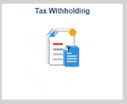

Update Work/Resident States Tile
Harvard expects individuals regularly and consistently working 20% or more of their time in a registered payroll state to allocate their time to that state for tax withholding purposes. For work that is on an informal, incidental basis, there is no need to change their withholdings. For example, an employee traveling to Maine for vacation would not need to change their withholdings if the individual sent some work emails during the trip.

NOTE: For the initial roll-out, employees working in California will not follow the below process, but will complete and submit appropriate California state tax forms via secure/encrypted email to janet_littlehale@harvard.edu and joanne_jordan@harvard.edu. Employees living and working in California are not expected to commute to another Harvard registered payroll state on a regular and consistent basis.

Steps

- Review work/resident state(s):
Before you add/edit your work/resident states and state tax information, you should update your home address information if that has changed by going to Home page > My Self Service tile > My Personal Details > Addresses. For students, please update your address in my.harvard or contact your school’s registrar with questions.
- Employees with a paid job in PeopleSoft prior to 9/27/21 will have state(s) listed based on tax information in PeopleSoft. (See note above regarding California).
- Employees hired after 9/27/21 will have a state listed based on their home address in PeopleSoft. (See Note above regarding California.)

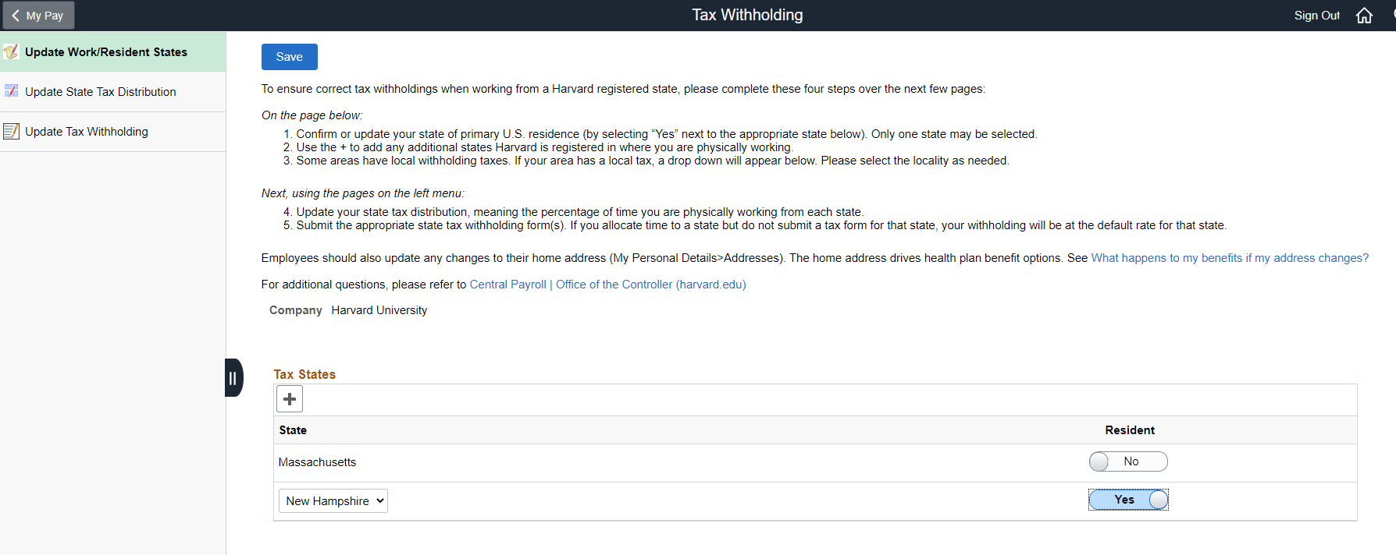

- Select “Yes” for the state that is your primary physical residence. Only one state may be selected as primary resident state.

Note: Some areas may have additional local or municipal tax withholding requirements. If applicable, an additional locality field will appear. Select the appropriate locality if appropriate.

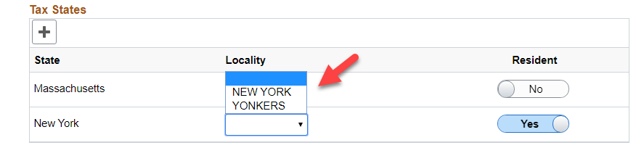
- If you are approved to be working in multiple Harvard registered states, add those states using the “+” button.

- Add as many Harvard registered states as needed.

- Select on the upper left-hand side of the screen.

Update State Tax Distribution Tile
Steps

- Update States Tax Distribution
- The Update States Tax Distribution tile will be populated based on the state(s) selected in the Update Work/Resident State screen. If a state is not showing, return to the Update Work/Resident State screen and add that Harvard registered payroll state.
- If you have multiple paid appointments, each job will be listed. Each job must be updated with the percent of distribution equaling 100%.

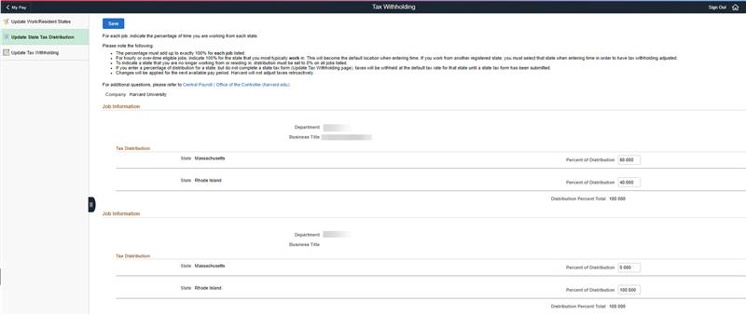

For Exempt Employees
Exempt employees are considered salaried employees who are not required to report their hours on a weekly basis. This includes those on the monthly payrolls (Faculty [MFC], Internal Postdocs [MIP] and Teaching Fellow [MTF]) exempt biweekly employees (PFX).

- Determine the percentage of time working in each Harvard registered state shown.
Enter the percent distribution into each state for each PeopleSoft job listed.

For example, if you work on campus 3 days a week and at home in NH 2 days a week, enter 60% time for time worked in Massachusetts and 40% time worked in New Hampshire.

NOTE:
- The percent of distribution for each job must equal 100%.
- To determine percentage of distribution, divide hours working in a specific state by the total scheduled hours (generally 35 for full-time employees). For the example about 14/35 = .40 or 40%.
- To inactive a state that i you are no longer residing or working from, set the percentage of distribution to “0.” Add or adjust other states as needed so the percentage of distribution equals 100% for each job. See Update Work/Resident States to add a state and adjust your primary physical residence.

- For the distribution percentage total to update, select “Save” or tab from one of the Percentage of Distribution fields to another. An error message will appear if the percentage of distribution does not add up to 100% for each job.
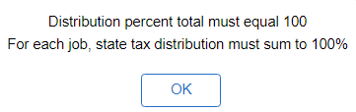
- Select on the upper left-hand side of the screen.

- This percentage of distribution will be used for next payroll cycle and any future payroll cycles.

- Add or remove states as needed.
- To inactivate a state that is you are no longer residing in or working from, set the percentage of distribution to “0.” Add or adjust other states as needed so the percentage of distribution equals 100% for each job. See Update Work/Resident States to add a state and adjust primary physical residence.

For Hourly / Overtime Eligible Employees (Time Reporters)
Hourly employees are employees who enter their hours on a weekly basis in PeopleSoft. This includes those on the biweekly payroll (POU, PON), weekly payroll (WTM, WPT, WRT)
Hourly employees must select only one state and would enter 100% for that state.

- Select the state where you will be working the majority of time.

If you will be working in New Hampshire 3 days a week and Massachusetts 2 days a week, enter 100% in New Hampshire.

This percentage of distribution will be the default for state tax withholdings unless you specify hours and work location when entering time in PeopleSoft (Navigation: Home page > My Self Service > My Time & Absences > Enter Time).

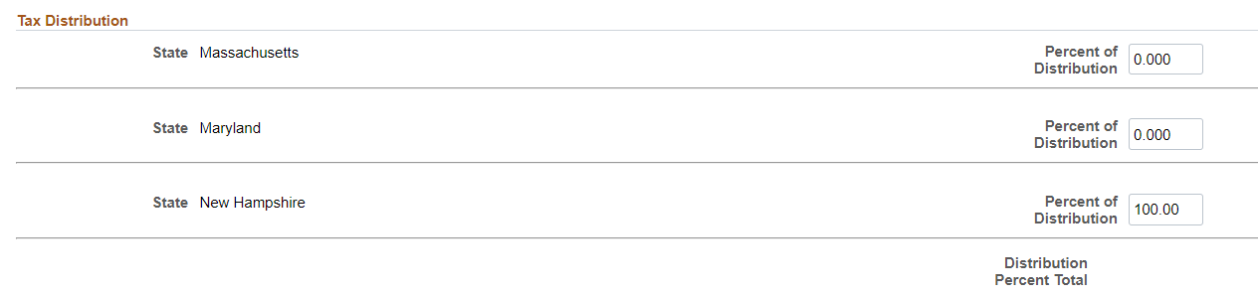

- For the distribution percentage total to update, select “Save” or tab from one of the Percentage of Distribution fields to another to update the percentage calculation. An error message will appear if the percentage of distribution does not add up to 100% for each job.
- Select t on the upper left-hand side of the screen.

- Add or remove states as needed.
- To inactivate a state that is you are no longer residing in or working from, set the percentage of distribution to “0.” Add or adjust other states as needed so the percentage of distribution equals 100% for each job. See Update Work/Resident States to add a state and adjust primary physical residence.

Update Tax Withholding Tile
Steps

- Review or Update federal and state(s) tax withholding.
- The states listed in this section are based on the states selected on the Update State Tax Distribution section. If a state is not listed, follow the steps in Update Work/Resident States and Update State Tax Distribution sections.
- Tax forms that are not completed but have a tax distribution selected will be taxed at the state’s default tax rate until a tax form submitted.
- Individuals working in New Hampshire will not need to complete a state tax withholding form; however:
  - exempt employees must have entered a percentage of effort in the Update State Tax Distribution section.
  - hourly / overtime eligible employees may have entered 100% percentage of distribution in New Hampshire if working the majority of time in that state or will select New Hampshire when entering time in PeopleSoft.

- The federal and state(s) will be listed based on information entered in the Update Work/Resident States and Update State Tax Distribution section. If a registered state is not listed, add the state in Update Work/Resident States and update the percentage of distribution in the Update State Tax Distribution section.

- Complete each tax form (federal and state(s) by clicking on each form type.
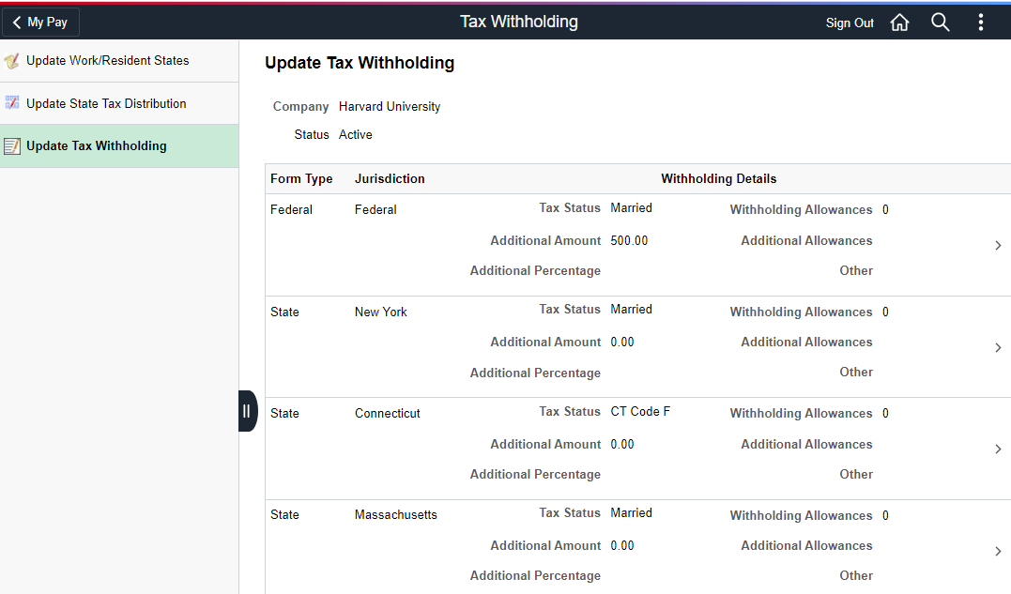

- Select “Updateable Forms – Form Description” and complete the specific federal or state tax form(s)

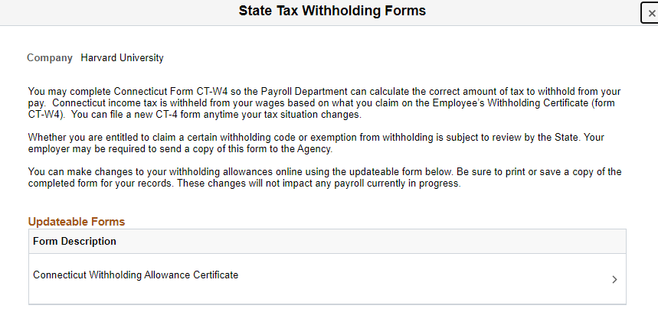
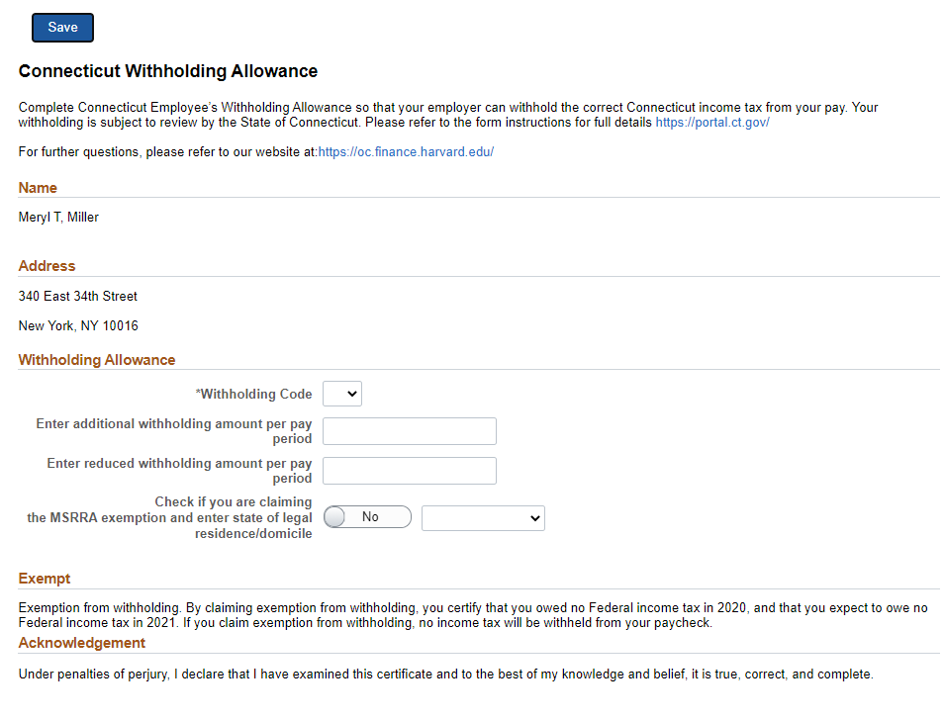

- Update the state tax forms as appropriate. A link to a state’s specific tax form instructions can be found at the top of the document. Some states may require local or municipal tax also be withheld (sometimes called locality taxes). These tax withholdings may be based on city, county, or school district boundaries. This withholding will be based on the same percentage selected for that state.
- Review your changes and the acknowledgement language and select

- Upon saving, you will receive the following message:

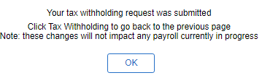

- Click OK

- You may print this page or select “Tax Withholding” to go back to the Update Tax Withholding tile, which will display your new withholding information. Verify that the changes are correct. Please note that, due to timing, your change may not be reflected on the next paycheck.
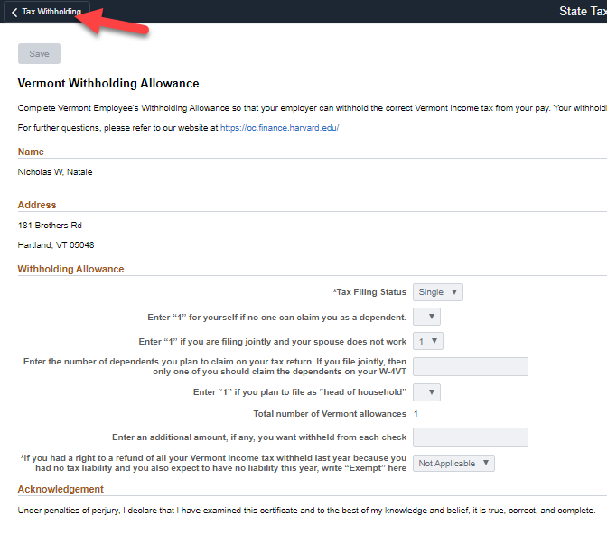

For help or more detailed information see the Office of the Controller Central Payroll website.

Due to local requirements, only exempt employees may be put on the California payroll (with the limited exception of nonexempt employees who already have established payroll arrangements in California prior to 9/1/2021).

